Project Synopsis – News Portal

# 1. Project Title:

News Portal

# 2. Objective:

To develop a responsive, dynamic, and user-friendly web application where users can post, read, search, and categorize news articles in real-time and admin can approve and delete the posted news.

# 3. Scope:

* - User can manage news content (add/edit/delete).
* - Users can view news by category (Politics, Technology, Sports, etc.).
* -Admin can review the news posted by users and will approve or disapprove it.
* - Responsive design for mobile and desktop.
* - Option for search, filter, and latest news highlights.

# 4. Modules:

* User Module:
* - View categorized news
* - Search functionality
* - Create, update, delete news articles
* - Manage categories and images
* Admin Module:
* - Login authentication
* - Manage Posted News (Approve / Delete)

# 5. Tools & Technologies:

* - Frontend: React, CSS, Bootstrap
* - Backend: Node JS, Express JS
* - Database: MongoDB
* - Tools: Visual Studio Code

# 6. Day-wise Development Plan:

1. **General Zone**

**Day 1&2 (Designing of General Zone’s Home Page):**

* **Menus and Slider**

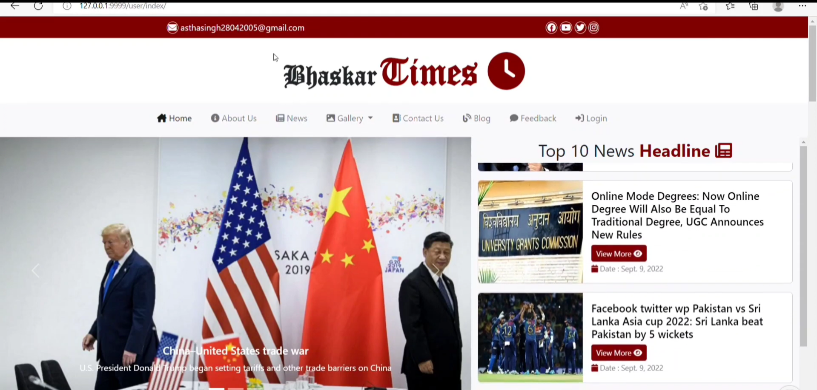

* **News Category**

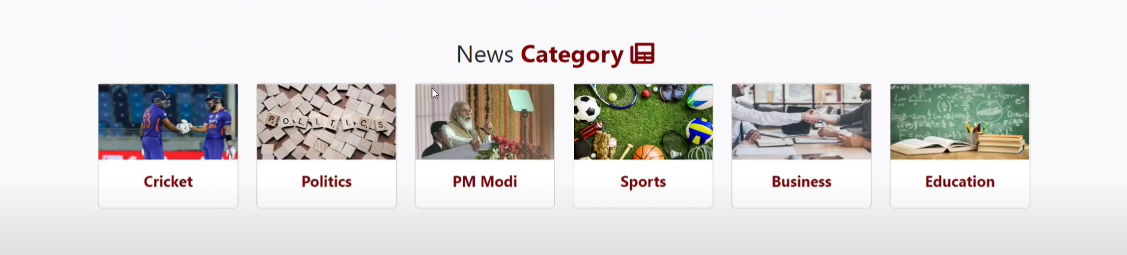

* **News Details**

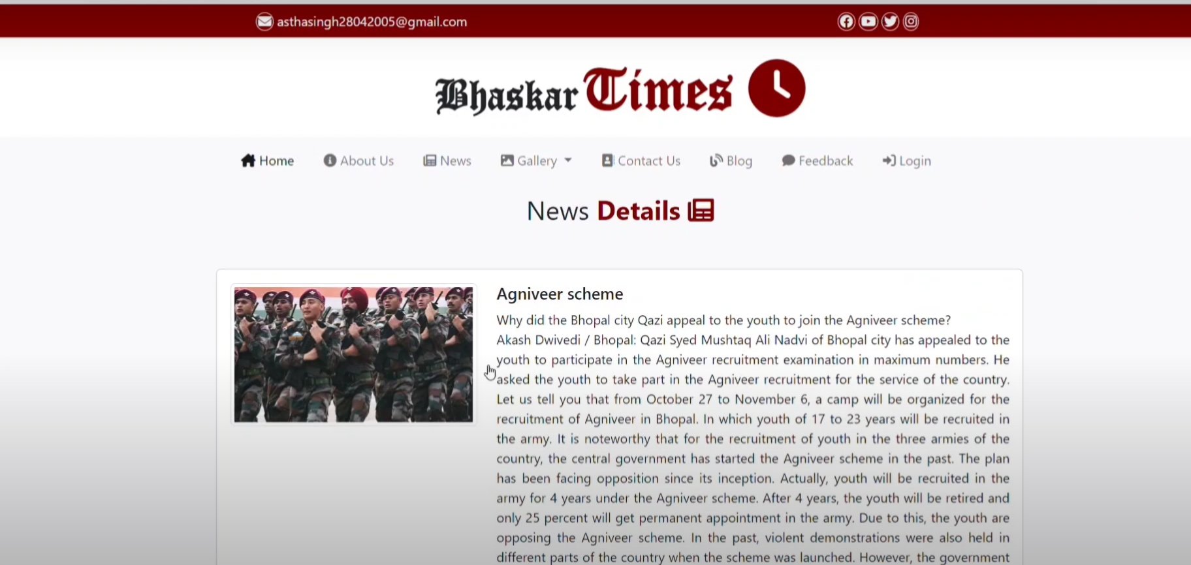

* **Latest News**

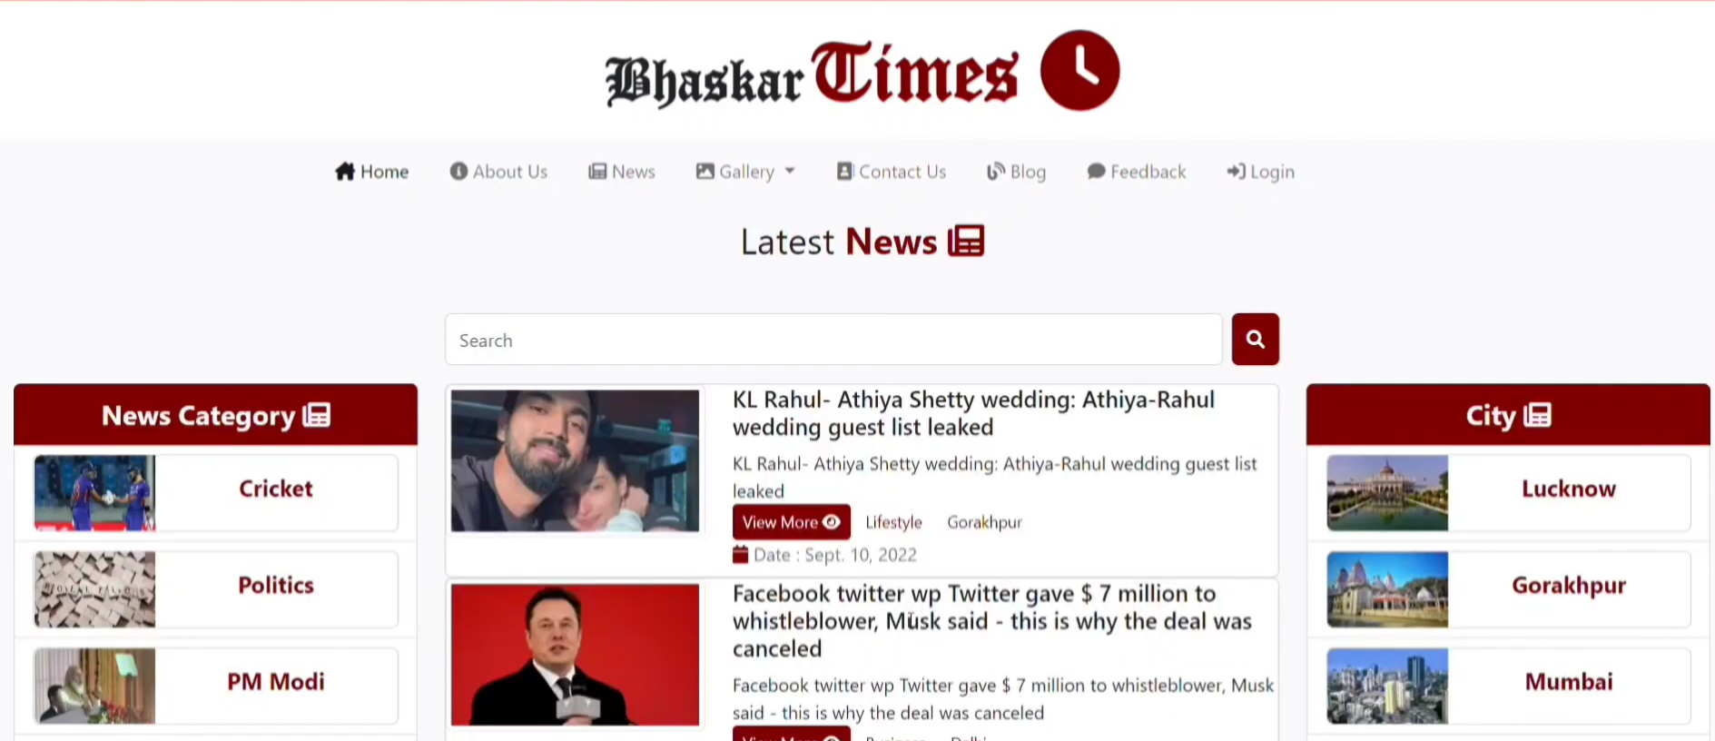

* **Latest Videos**

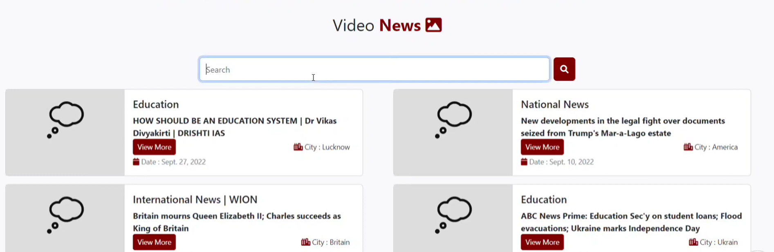

* **Cities**

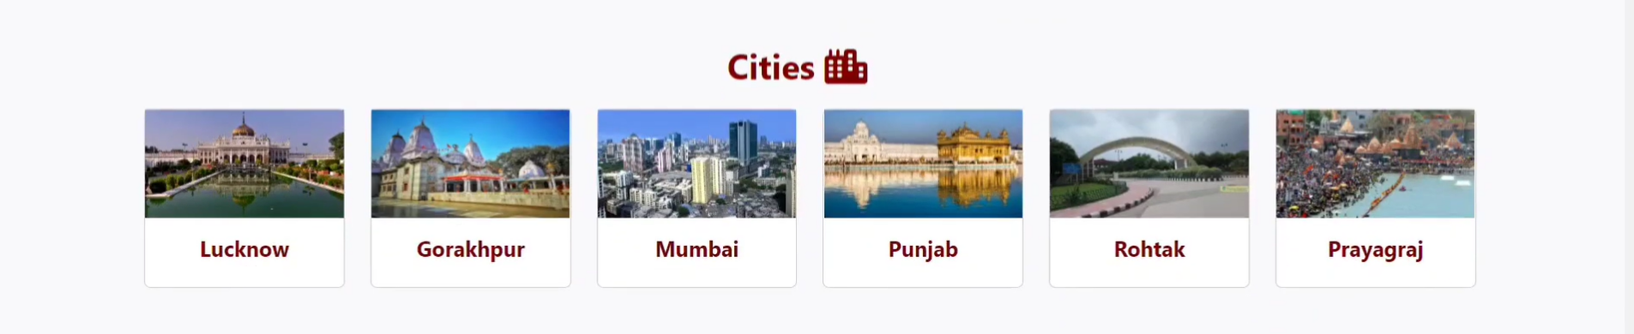

* **Image Gallery**

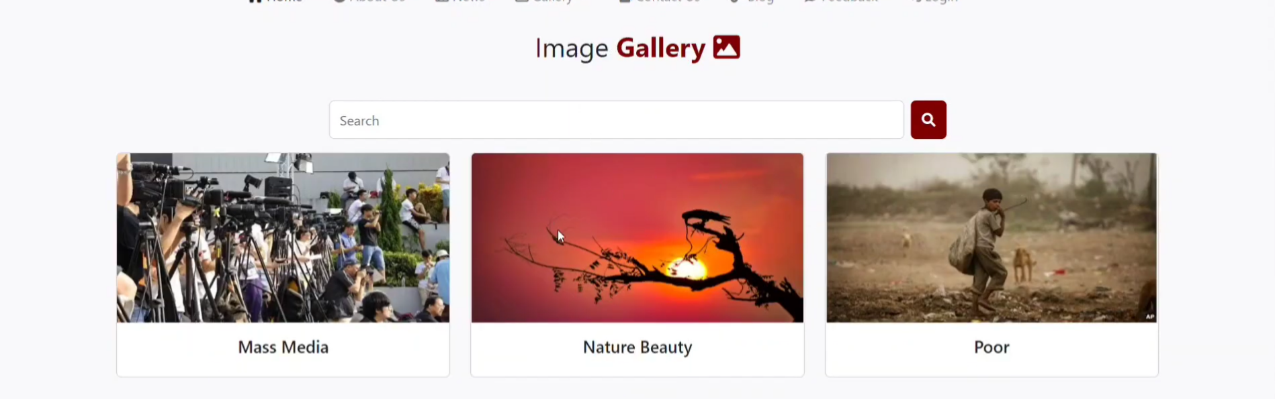

* **Contact Us**

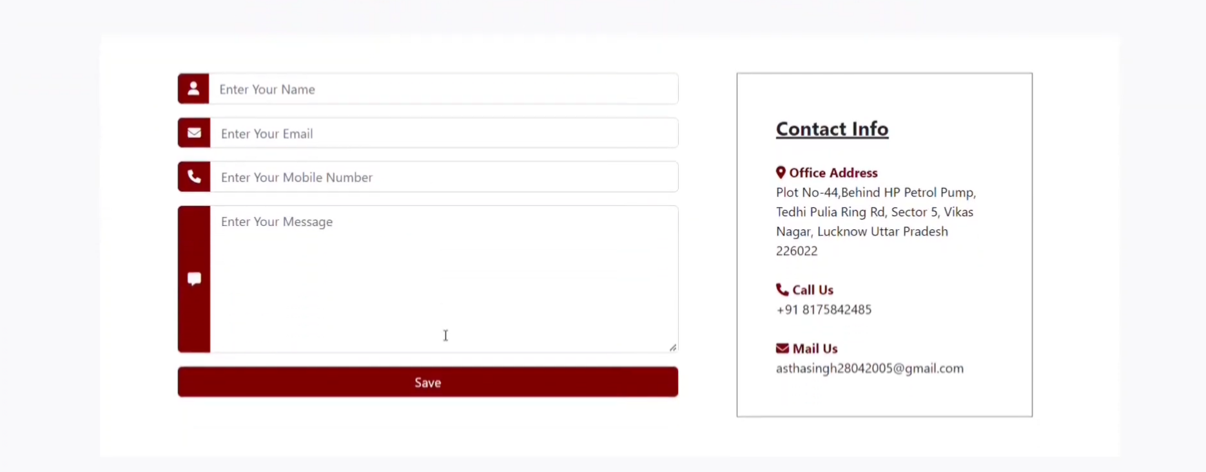

* **About Us**

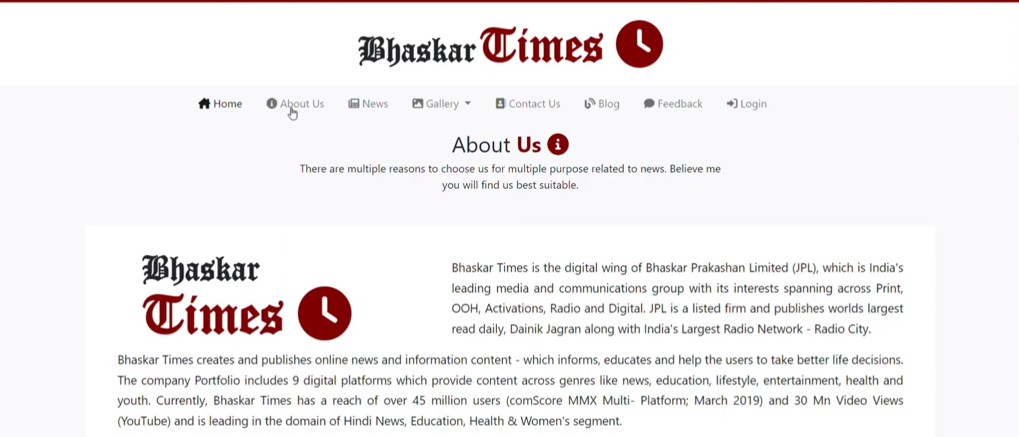

* **Feedback**

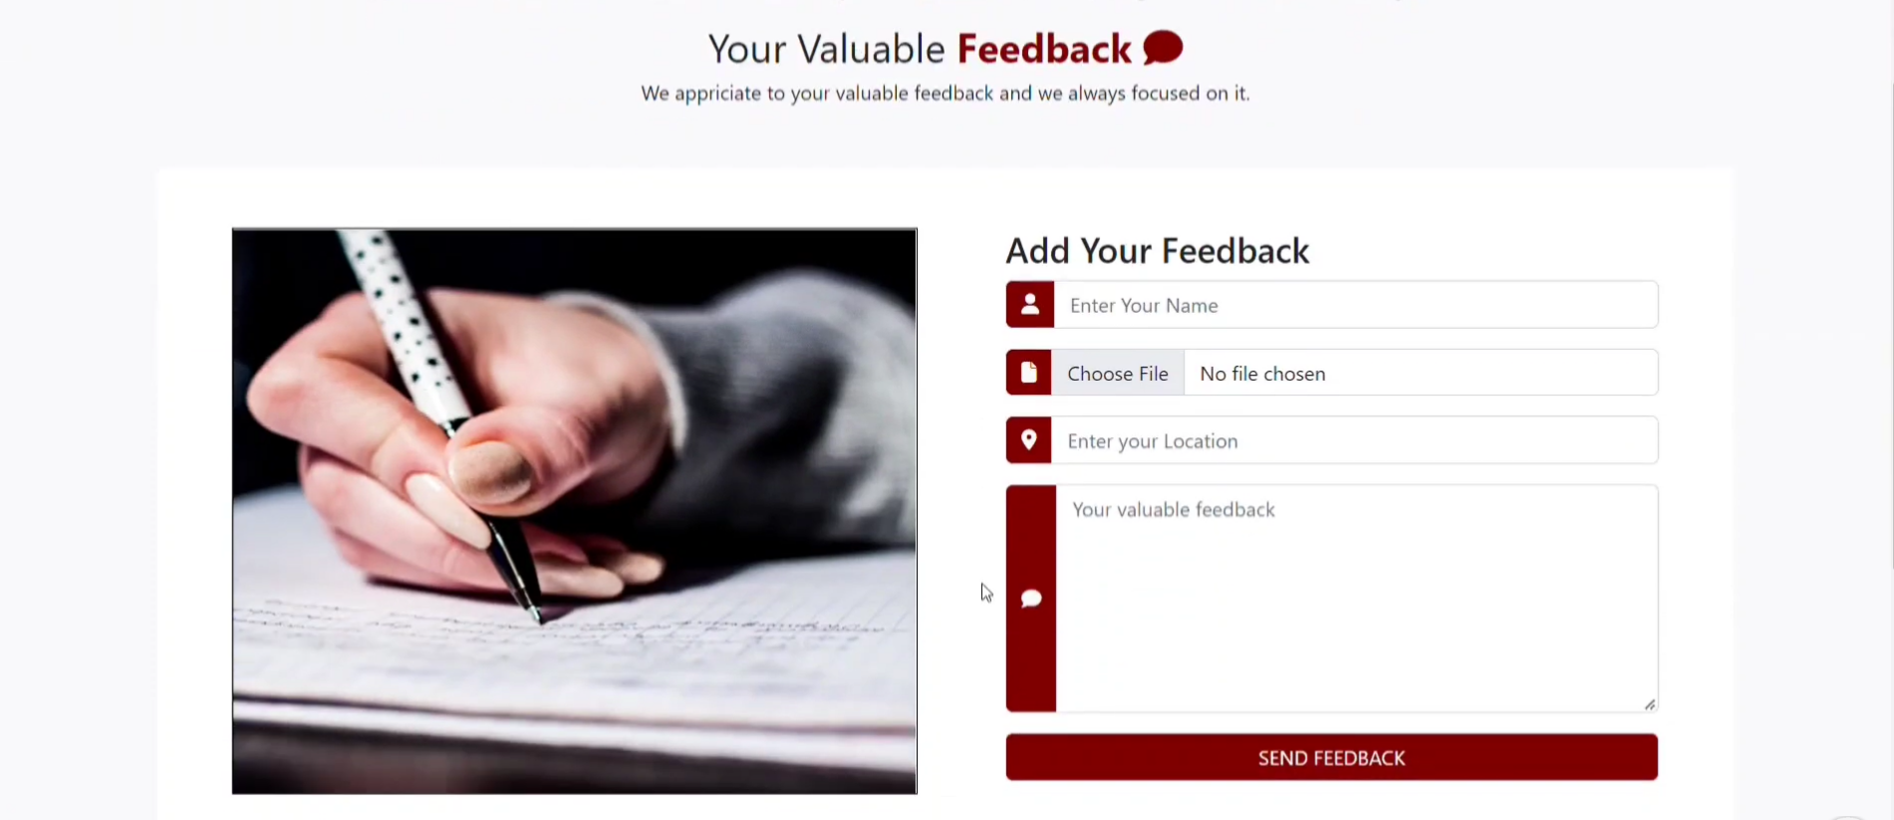

* **Footer**

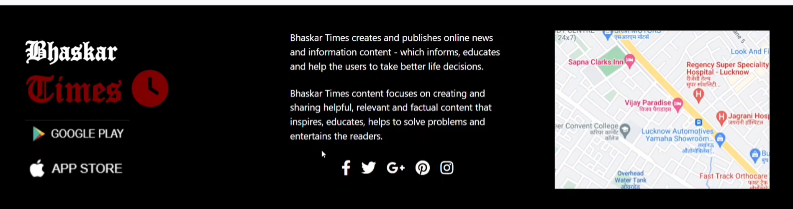

**Folder Structure**

